Kit boxes for Sound Matters
1. Whirly tubes (80cm long)
2. Tibetan bells
How to hold the Tibetan bells. Hold the string above each bell and strike one against the other. You can then move the bells around each other to get lovely sound effects.
3. Middle Human Ear Model
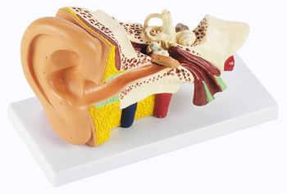
4. Foam ear plugs
5. Plastic rulers
6. Slinky spring
7. Magnetic paper and magnetic receptive flex-o-metal A4 sheets. The picture of the ear can be stuck onto the flex-o-metal material and the labels printed on magnetic paper. Both sheets can be covered in sticky-back plastic to make them more durable. https://www.abelmagnets.com/

