The Physics Bit

A teacher’s guide to the physics of Growing Sound

What are these notes for?
These notes are just here to give you a bit of background on the physics that crops up in a Growing Sound workshop. We don’t intend you to teach the information in these notes to your pupils because a lot of it is Key Stage 3 or even Key Stage 4 level. It’s purely here as background for you, the teacher, and hopefully it will be useful.

A definition to start with…
Everyone has heard of physics, but what exactly does it mean? Well, physics is the science of matter and energy and its interactions. So that actually covers pretty much everything – including sound. Sound is a form of energy and it interacts with matter so it is definitely a part of physics.

What exactly is sound then?
Sound is a form of energy. It is a vibration that travels as a wave through a medium. That medium can be a solid, liquid or gas. The thing about sound is that it has to have something to travel through. Because it is a vibration there has to be something to vibrate or sound can’t travel.

When you next watch Star Trek, or pretty much any other sci-fi programme with space ships in it, you will notice that they make a fantastic roaring noise as they zoom past. Wrong, wrong, wrong. Space is a vacuum. There is no ‘stuff’ in space to vibrate, therefore the sound from the spaceship’s engine would not be able to travel away from the spaceship to reach anyone else.

The Physics Bit
A teacher’s guide to the physics of Growing Sound

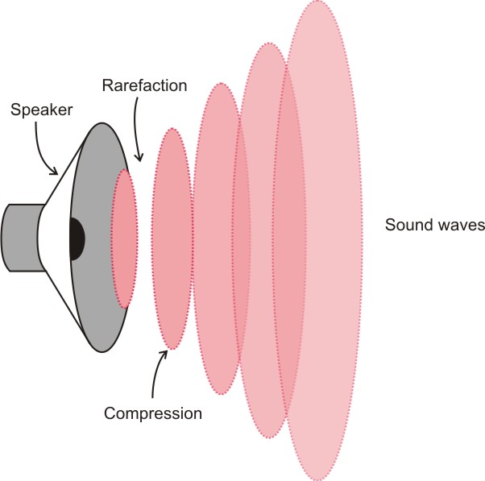
How does a sound wave work?
If you play a really loud deep bass note through a speaker you can see the speaker cone vibrating. When the speaker cone moves forward it squashes or compresses the air in front of it. When it moves backwards it stretches or rarefies the air in front of it. These areas of compression and rarefaction then spread out from the speaker like ripples on the surface of a pond.

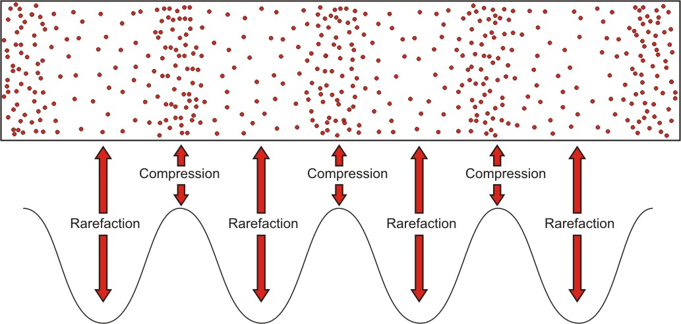
We can draw a sound wave like this, where the areas of compression are the peaks in the wave and the areas of rarefaction are the troughs.

It is really important to be clear that the particles move backwards and forwards about a point. They do not ‘carry the sound’ from the speaker to our ears. The sound energy is passed from particle to particle through the medium (solid, liquid or gas).

The Physics Bit
A teacher’s guide to the physics of Growing Sound

What makes sound?

Anything that vibrates makes sound. Whether we can hear the sound or not depends on how fast the thing vibrates. Things that vibrate very quickly will make high pitched sounds. Things that vibrate very slowly will make low pitched sounds. Humans can’t hear sound above a certain pitch, but many animals are able to hear sounds way out of range of human hearing. Sound which is above the range of human hearing is called ultrasound.

Humans also can’t hear sound below a certain pitch. Again, certain animals such as elephants can make and hear this sound. Sound which is below the range of human hearing is called infrasound.
Bats are able to hear sounds beyond the range of human hearing

What is the frequency of a sound?
The frequency of a sound is what we hear as pitch. High pitch sounds have a high frequency and low pitch sounds have a low frequency.

If you want to get a bit more scientific take a look at the wave diagram below. If you imagine that you are stationary and the sound wave is speeding past you the frequency is the number of complete cycles that would rush past you in one second. By the way, a complete cycle is just the biggest chunk of wave you can get before it starts repeating itself – the part of the diagram outlined in red shows a complete cycle.
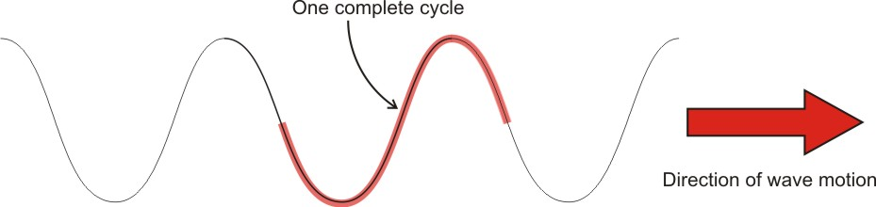

The Physics Bit
A teacher’s guide to the physics of Growing Sound

Frequency is measured in hertz and abbreviated to Hz. If a sound has a frequency of 100 Hz, this means that one hundred complete cycles of that sound wave would rush past you in one second if you were standing stationary as it went by.

What you can hear
Human beings can hear sounds as low as 20 Hz and as high as 20 000 Hz (20 kHz). However, as you get older the highest frequency you can hear tends to decrease.

This means that sounds below 20 Hz are called infrasound and sounds above 20 kHz are called ultrasound.

I’ve heard of ultrasound…
Ultrasound is really useful. It is used in a huge number of different applications from cleaning small, delicate mechanical parts to some types of humidifiers. However, it is probably best known for its medical imaging uses.

Depending on exactly what you want to image sound waves of between 2 and 18 million hertz (MHz) are transmitted into a patient’s body and the echoes are recorded. From the echoes a computer can produce an image of what’s going on inside.

The Physics Bit
A teacher’s guide to the physics of Growing Sound

In case you wanted to know…
There are two other important properties of waves you might like to know about.

Wavelength – this is simply the distance separating two adjacent peaks of a wave. It is measured in metres. (High frequency sounds have short wavelengths and low frequency sounds long wavelengths).
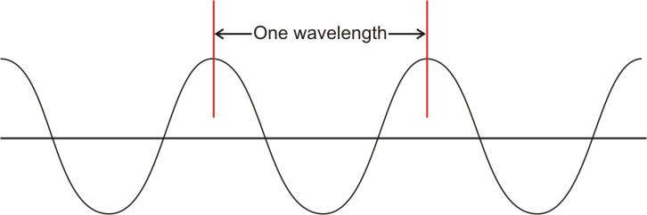

Amplitude – this is the height from the centre of the wave to the top of one of the peaks. Again it is measured in metres (or sometimes centimetres). The bigger the amplitude, the more energy the sound wave is carrying and the louder it is.

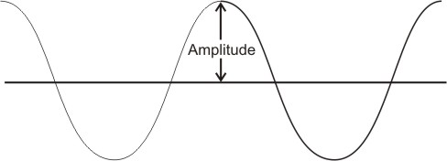

How fast does sound travel?
Well that depends on what it is travelling through.

Remember that sound is a vibration. In a gas, the particles are generally quite far apart so it takes a while before they manage to bang into each other. This means that sound travels through a gas relatively slowly. In air at sea level sound travels at about 330 metres per second.

The Physics Bit
A teacher’s guide to the physics of Growing Sound

In a liquid the particles are a bit closer together so the vibration gets passed on more quickly than in a gas. In water, sound travels at about 1 500 metres per second.

In a solid, because the particles are closer together, the vibration gets passed on very quickly. Sound can travel pretty fast through a solid. For example, sound travels through steel at 5 100 metres per second. But the speed of sound in a solid does depend on exactly what solid you’re talking about. If we take the metal beryllium we find that sound travels through it at a whopping 12 870 metres per second.

